**EXPERIMENT NO:** 2 **DATE:**

**TITLE:** **Non–Pre-emptive CPU Scheduling Algorithm**

**AIM:** To implement **First Come First Serve (FCFS)** Scheduling Algorithm.

**THEORY**

**What is Non-Pre-emptive CPU Scheduling Algorithm?**

A **Non-Pre-emptive CPU Scheduling Algorithm** is a scheduling method in which once a process starts execution on the CPU, it **cannot be interrupted** until it finishes its execution. The CPU will not be given to another process, even if another process arrives with higher priority.

This is in contrast to **pre-emptive scheduling**, where a running process can be interrupted and moved back to the ready queue if a higher-priority process arrives.

**First Come First Serve (FCFS) Scheduling**

**Working Principle**

* FCFS is the **simplest non-pre-emptive scheduling algorithm**.
* It follows the **FIFO (First In, First Out)** rule:
  1. Processes are executed in the order they arrive in the ready queue.
  2. The process that arrives first gets the CPU first.
  3. Once a process starts execution, it runs till completion before the next process starts.
* It is fair, but may lead to the **Convoy Effect** (long processes delaying shorter ones).

**Steps for FCFS Scheduling**

1. **Sort** processes according to **Arrival Time (AT)**.
2. **Calculate Completion Time (CT)**: The time at which the process finishes execution.
3. **Calculate Turnaround Time (TAT)**:

TAT=CT−AT

**Calculate Waiting Time (WT)**:

WT=TAT−BT

**Calculate Averages** for WT and TAT.

**Solved Example**

**Given:**

| **Process** | **Burst Time (BT)** | **Arrival Time (AT)** |
| --- | --- | --- |
| P1 | 5 | 0 |
| P2 | 3 | 1 |
| P3 | 8 | 2 |

**Step 1: Sort by Arrival Time (Already Sorted)**

**Step 2: Calculate Completion Time (CT)**

* **P1**: CT = 0 + 5 = 5
* **P2**: CT = 5 + 3 = 8
* **P3**: CT = 8 + 8 = 16

**Step 3: Calculate TAT**

TAT=CT−AT

* P1: 5 − 0 = **5**
* P2: 8 − 1 = **7**
* P3: 16 − 2 = **14**

**Step 4: Calculate WT**

WT=TAT−BT

* P1: 5 − 5 = **0**
* P2: 7 − 3 = **4**
* P3: 14 − 8 = **6**

**Step 5: Calculate Averages**

* **Average WT (AWT)** = (0 + 4 + 6) ÷ 3 = **3.33**
* **Average TAT (ATAT)** = (5 + 7 + 14) ÷ 3 = **8.67**

**Gantt Chart**

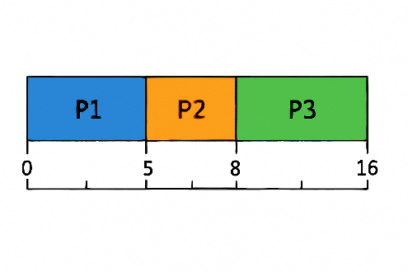

**Final Table**

| **Process** | **BT** | **AT** | **CT** | **TAT** | **WT** |
| --- | --- | --- | --- | --- | --- |
| P1 | 5 | 0 | 5 | 5 | 0 |
| P2 | 3 | 1 | 8 | 7 | 4 |
| P3 | 8 | 2 | 16 | 14 | 6 |

**Average Waiting Time (AWT)** = 3.33  
**Average Turnaround Time (ATAT)** = 8.67

|  |  |
| --- | --- |
| #include <iostream> #include <iomanip>  using namespace std;    int order[10];    int *average*(int *matrix, int n) { int avg = 0;  for (int i = 0; i < n; i++) avg += matrix[i];  return avg / n;  }    void *sort_arr*(int arr[], int n) { int copy[n];  for (int i = 0; i < n; i++) { order[i] = i;  copy[i] = arr[i];  }  for (int i = 0; i < n - 1; i++) { for (int j = i + 1; j < n; j++) { if (copy[i] > copy[j]) { int temp = copy[i]; copy[i] = copy[j];  copy[j] = temp;    int t = order[i]; order[i] = order[j]; order[j] = t;  }  }  }  }    void *calc*(int burst[], int arr[], int n) { *sort_arr*(arr, n);  int complete[n], TAT[n], WT[n], time = 0;    for (int i = 0; i < n; i++) { time += burst[order[i]]; | complete[order[i]] = time; } for (int i = 0; i < n; i++)  TAT[i] = complete[i] - arr[i]; for (int i = 0; i < n; i++) WT[i] = TAT[i] - burst[i]; cout *<<* "*\n*Gantt Chart:*\n*";  cout *<<* " ";  for (int i = 0; i < n; i++) cout *<<* "-------"; cout *<<* "*\n*|";  for (int i = 0; i < n; i++)  cout *<<* " P" *<<* order[i] + 1 *<<* " |"; cout *<<* "*\n* ";  for (int i = 0; i < n; i++) cout *<<* "-------"; cout *<<* "*\n*0"; for (int i = 0; i < n; i++)  cout *<<* *setw*(7) *<<* complete[order[i]]; cout *<<* "*\n\n*";  cout *<<* "Process*\t*BT*\t*AT*\t*TAT*\t*WT*\n*";  for (int i = 0; i < n; i++) { cout *<<* "P" *<<* i + 1 *<<* "*\t*"  *<<* burst[i] *<<* "*\t*"  *<<* arr[i] *<<* "*\t*"  *<<* TAT[i] *<<* "*\t*"  *<<* WT[i] *<<* *endl*; }  cout *<<* "*\n*Average waiting time : " *<<* *average*(WT, n);  cout *<<* "*\n*Average turn-around time : " *<<* *average*(TAT, n);  }  int *main*() {  int n;  cout *<<* "Enter number of processes: "; cin *>>* n;    int burst[n], arr[n];  for (int i = 0; i < n; i++) {  cout *<<* "Process " *<<* i + 1 *<<* *endl*; cout *<<* "Enter Burst Time: "; |
| cin *>>* burst[i];  cout *<<* "Enter Arrival Time: "; cin *>>* arr[i];  }    cout *<<* *endl*; *calc*(burst, arr, n); return 0;  } |  |

**OUPUT:**

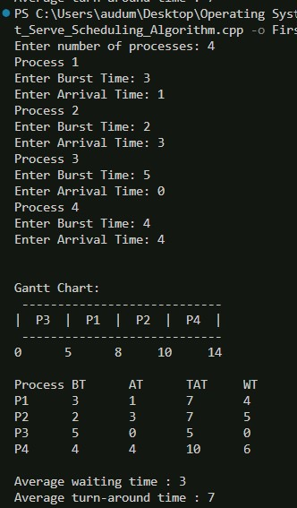

**Conclusion:**first come first serve cpu scheduling algorithm was implemented successfully in cpp.